AWS NAT Gateway Mini Project
Project: Private EC2 Internet Access through NAT Gateway
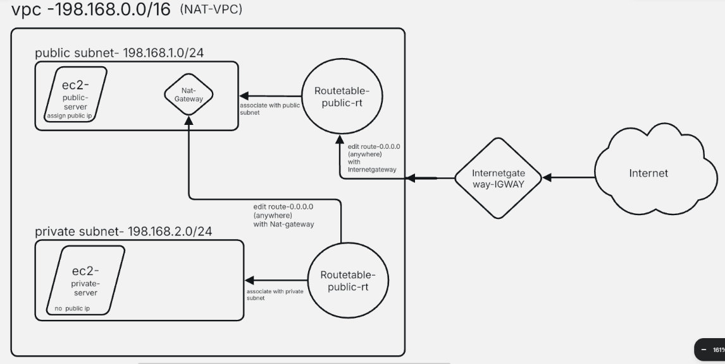
Architecture-
Internet
|
Internet Gateway
(IGWAY)
|
NAT-VPC
---------------------------------
| |
Public Subnet Private Subnet
(10.0.1.0/24) (10.0.2.0/24)
| |
Public Server Private Server
(Public IP) (No Public IP)
| |
NAT Gateway <-----------------------

Step 1: Create VPC-
Go to VPC → Create VPC
Name | nat-vpc
IPv4 CIDR | 198.168.0.0/16
Click Create VPC
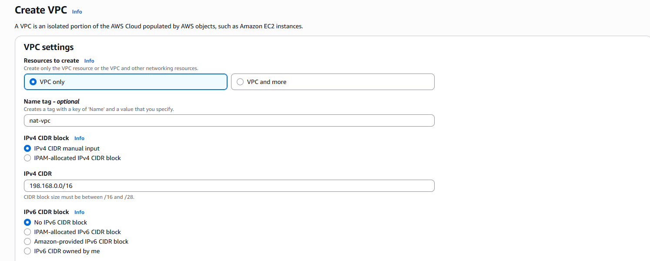

Step 2: Create Public Subnet-
Go to Subnets → Create subnet
Name | public-subnet
VPC | nat-vpc
AZ | Any (example ap-south-1a)
CIDR | 198.168.1.0/24
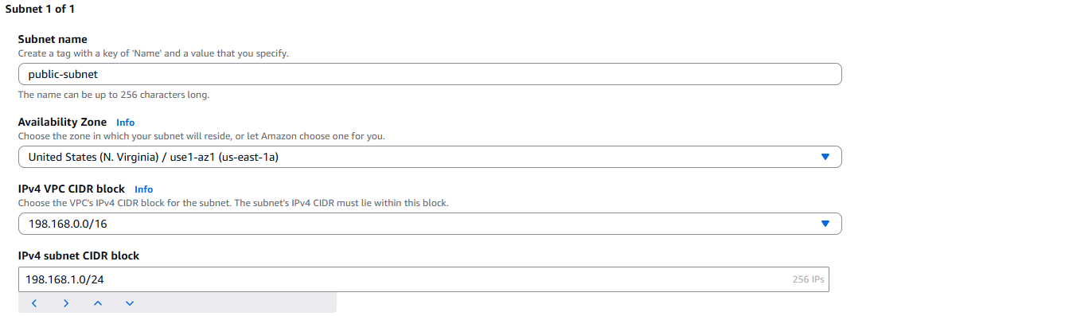

Step 3: Create Private Subnet-
Create another subnet.
Setting | Value
Name | private-subnet
VPC | nat-vpc
AZ | Same AZ
CIDR | 198.168.2.0/24
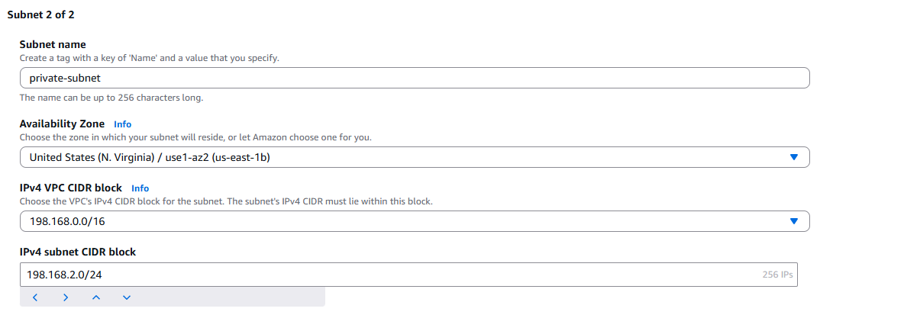
Step 4: Create Internet Gateway-
Go to- Internet Gateway → Create
Name-IGWAY
Create. Now
Actions → Attach to VPC
Select- nat-vpc
Attach. 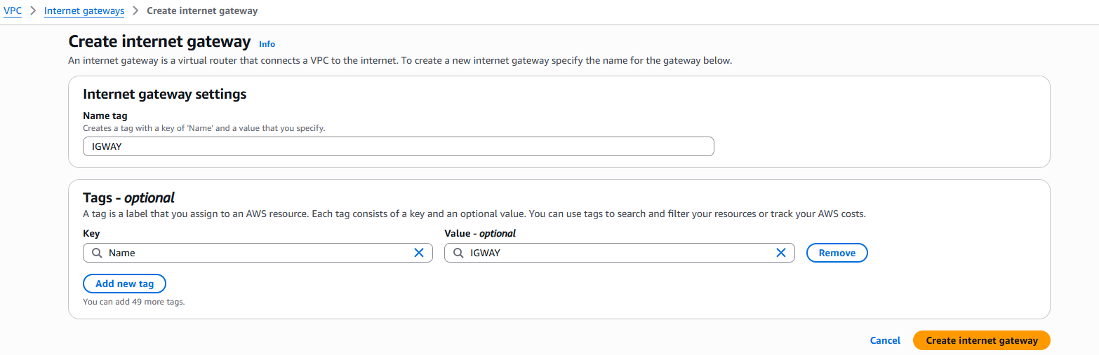
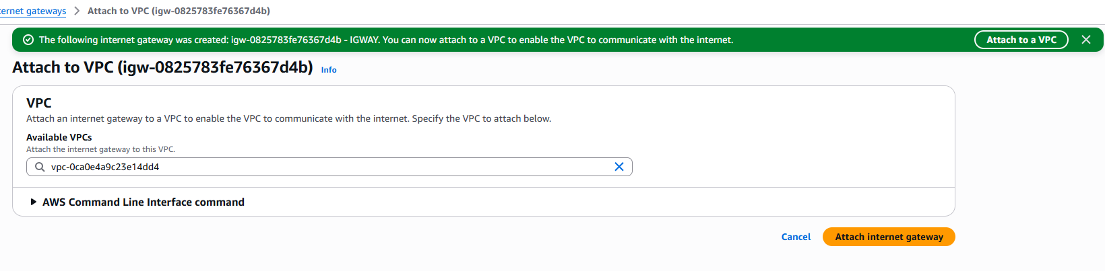

Step 5: Create Public Route Table-
Go to-Route Tables → Create
Name | -public-rt
VPC- | nat-vpc
Create.
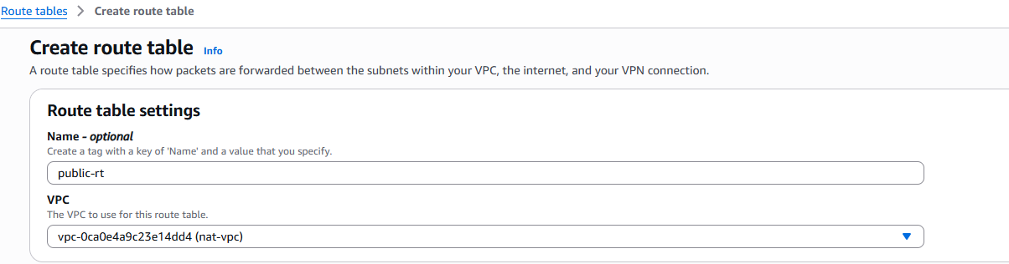
Edit Routes
Add
Destination | Target
0.0.0.0/0 | Internet Gateway (IGWAY)
Save.
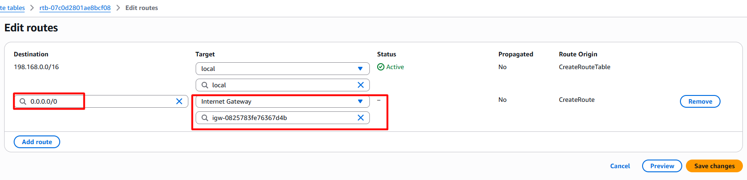
Associate Subnet
Associate
public-subnet
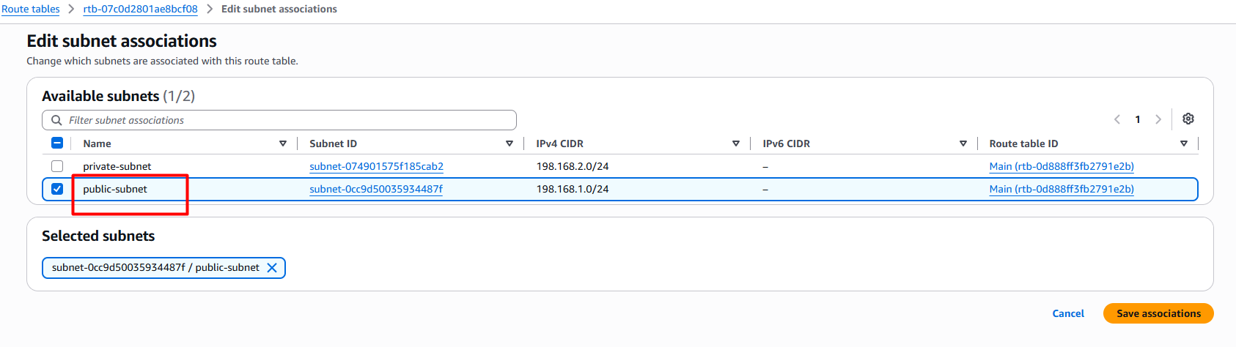

Step 6: Create Private Route Table-
Create Route Table
Name-private-rt
VPC-nat-vpc
Create.
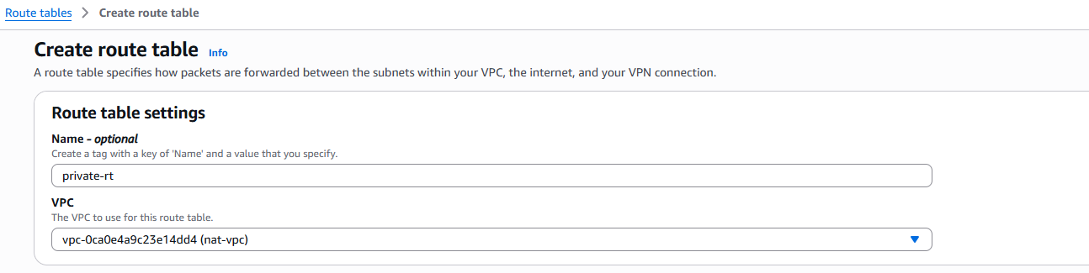
Do not add route yet.
Associate
private-subnet
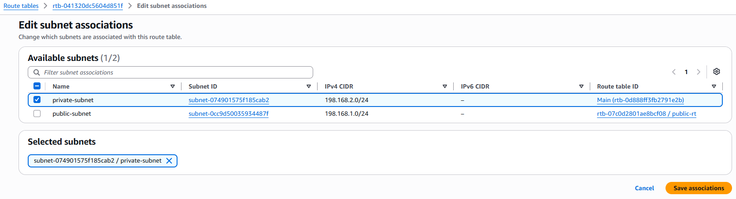

Step 7: Launch Public EC2-
Launch EC2
Setting | Value
Name | public-server
AMI | RHEL
Instance | T3.micro
VPC | nat-vpc
Subnet | public-subnet
Public IP | Enable
Security Group | Default (Auto)
Launch.
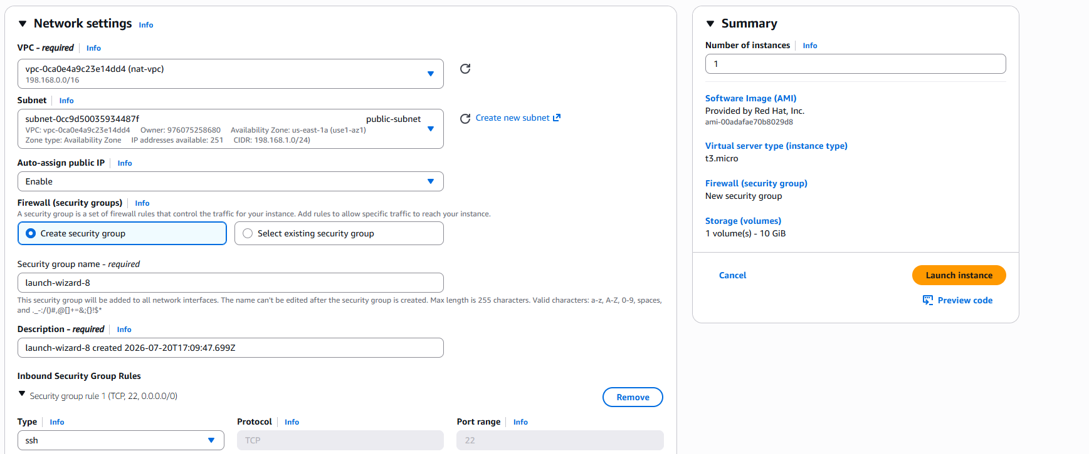

Step 8: Launch Private EC2
Launch another EC2
Setting | Value
Name | private-server
AMI | RHEL
Instance | t2.micro
VPC | nat-vpc
Subnet | private-subnet
Public IP | Disable
Security Group | Default (Auto)
Launch.
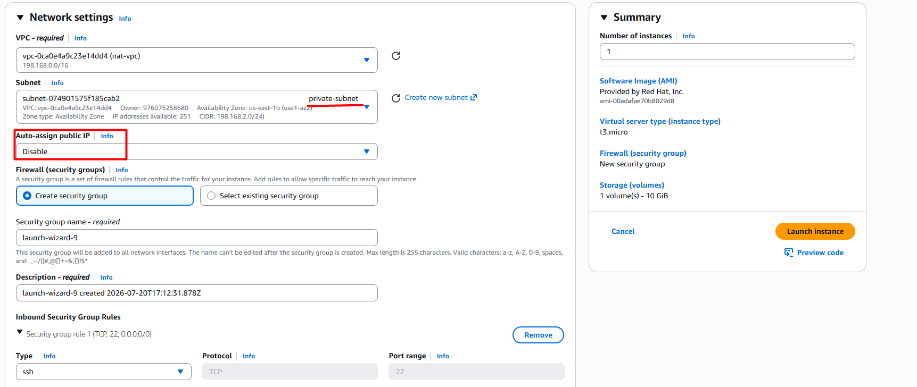

Step 9: Create NAT Gateway-
Go to
NAT Gateway
Create NAT Gateway.
Setting | Value
Name | nat-gateway
Subnet | public-subnet
Elastic IP | Select allocated EIP
Click-Create.
Wait until Status becomes -Available
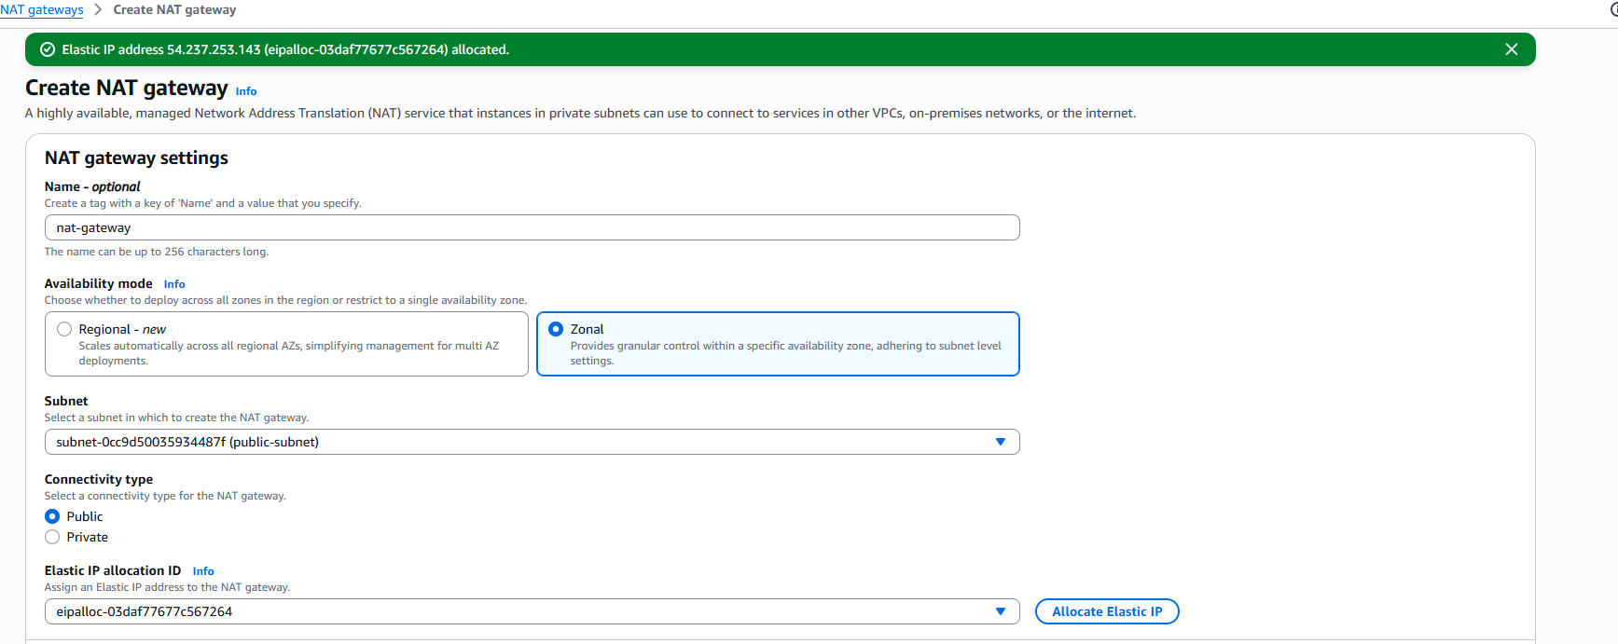

Step 10: Edit Private Route Table-
Open -> private-rt ->Edit Routes
Add
Destination | Target
0.0.0.0/0 | NAT Gateway
Save.
Now private subnet traffic goes
Private Server
↓
NAT Gateway
↓
Internet Gateway
↓
Internet
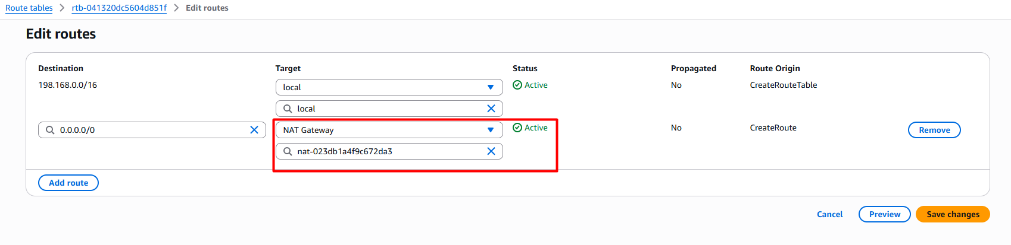

Step 11: Connect to Public Server-
SSH- ssh -i "united-northvirginia-home.pem" ec2-user@<Public-IP>
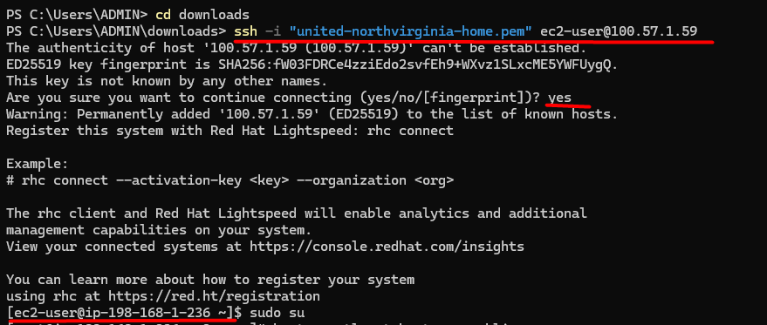

Step 12: Connect to Private Server-
Create private key to the public server:
# vi sagar_key.pem
paste private key content of public server in vi editor
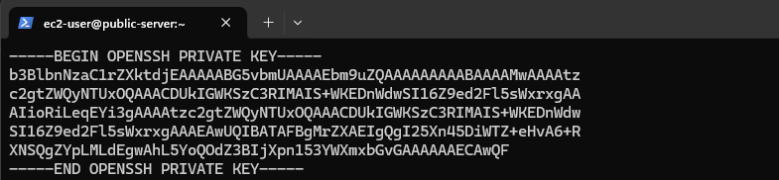
On the public server:
# chmod 700 sagar_key.pem
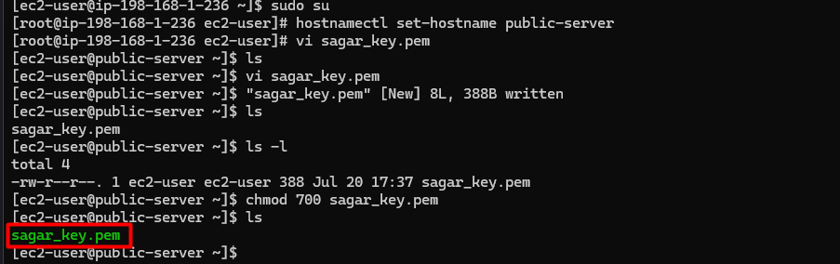
SSH to the private server:
ssh -i “sagar_key.pem” ec2-user@<Private-IP>
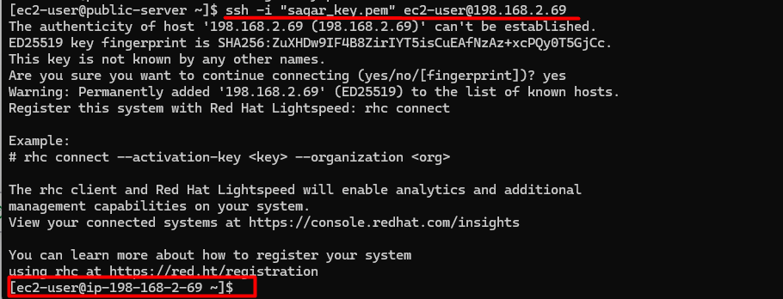

Step 13: Test Internet on Private Server
Check the external IP: $ curl ifconfig.me
Update packages: $ sudo yum update -y
If packages download successfully, the private server has outbound internet access through the NAT Gateway.
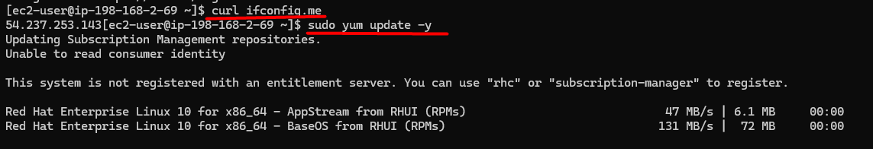

Step 14: Verify-
Run: ping google.com
If these work, NAT Gateway is functioning correctly.

Traffic Flow
Private Server
▼
Private Route Table
0.0.0.0/0
▼
NAT Gateway
▼
Internet Gateway
▼
Internet
Key Questions-
- Why can't the private server access the internet directly?
  - It has no public IP and no direct route to the Internet Gateway.
- Why is the NAT Gateway placed in the public subnet?
  - It requires a public subnet with a route to the Internet Gateway and an Elastic IP to forward outbound traffic.
- Can the internet initiate connections to the private server through the NAT Gateway?
  - No. A NAT Gateway only allows outbound connections initiated from the private instances and the corresponding return traffic.
- Why do we use an Elastic IP with a NAT Gateway?
  - The Elastic IP provides a fixed public IP address that the NAT Gateway uses for outbound internet communication.
- Can multiple private EC2 instances share one NAT Gateway?
  - Yes. A single NAT Gateway can provide outbound internet access for multiple instances in private subnets within the same Availability Zone.
This project is a common AWS networking interview scenario and demonstrates how to securely provide internet access to private EC2 instances while keeping them inaccessible directly from the internet.

